Copyright 2007, Society of Petroleum Engineers

SPE 110331
Flow Through Inhomogeneous Fault Zones
Harald H. Soleng, Anne Randi Syversveen, Arne Skorstad, SPE, Per Røe, Norwegian Computing Center, and Jan Tveranger, CIPR, University of Bergen

This paper was prepared for presentation at the 2007 SPE Annual Technical Conference and Exhibition held in Anaheim, California, U.S.A., 11–14 November 2007.

This paper was selected for presentation by an SPE Program Committee following review of information contained in an abstract submitted by the author(s). Contents of the paper, as presented, have not been reviewed by the Society of Petroleum Engineers and are subject to correction by the author(s). The material, as presented, does not necessarily reflect any position of the Society of Petroleum Engineers, its officers, or members. Papers presented at SPE meetings are subject to publication review by Editorial Committees of the Society of Petroleum Engineers. Electronic reproduction, distribution, or storage of any part of this paper for commercial purposes without the written consent of the Society of Petroleum Engineers is prohibited. Permission to reproduce in print is restricted to an abstract of not more than
300 words; illustrations may not be copied. The abstract must contain conspicuous acknowledgment of where and by whom the paper was presented. Write Librarian, SPE, P.O. Box 833836, Richardson, Texas 75083-3836 U.S.A., fax 01-972-952-9435.

Abstract
Faults significantly influence fluid flow in reservoirs. In standard reservoir flow-simulator grids, faults are represented as surfaces or planes. However, outcrop studies show that faults often must be regarded as volumetric elements. Inside such fault zones, the facies characteristics differ significantly from those in the rest of the reservoir. In a fault facies reservoir model faults are represented as volumes populated with facies with properties derived from their origin and faulting history.

In this paper, we compare fluid flow performance of a fault facies model and a conventional fault model. The uncertainties attached to the fault zone properties and architecture included in the fault facies model produce a straightforward effect on the range of simulation outcomes and uncertainty of production parameters. In the conventional model, similar effects can only be reproduced ad hoc using poorly determined random fudge factors. We also look at the effect of upscaling the fault zone. Results show that the flow properties in the fault facies model differ from the conventional model with regard to both water cut and total oil production. As expected, upscaling may introduce a significant bias in the cumulative oil production.

Introduction

Faults most commonly act as barriers for fluid flow, but sometimes they act as conduits. In order to perform reliable forecasting of production performance, it is crucial to understand the causes for this contrasting behavior, and capture them properly in the reservoir model.

Faults normally occupy a negligible fraction of the total volume of a petroleum reservoir, and fault thicknesses are commonly significantly smaller than cell dimensions used in reservoir models. It may therefore seem natural to model faults as membrane-like two-dimensional slip surfaces. Faults display different sealing properties. This is chiefly due to contrasting or varying host rock properties, displacement magnitudes and tectonic development. In conventional flow models, transmissibility multipliers represent the fault sealing effects. Non-neighboring connections take care of flow along the slip plane.

Industry-standard flow simulators translate all permeabilities into transmissibilities. Hence, any permeability field could just as well be represented as a transmissibility field. From this perspective, the traditional fault model is fully adequate.

In reality, a fault zone is a complex three-dimensional object where host rock facies from different zones are mixed and transformed into new, tectonized facies types. It is clear that without a proper stochastic model based on the physics of faults, it is impossible to determine and quantify the uncertainty of all its flow properties. The fault facies model¹ addresses this problem by advocating detailed modeling of fault zones.

The present paper compares impact on modeled reservoir fluid flow of the two modeling approaches by using a synthetic model of multi-phase oil reservoir with one water injector well and one oil production well separated by a single large fault.

The models
In this paper we consider a synthetic reservoir containing high permeable sand bodies in a background of shale with a fault with varying displacement cutting through the whole region. Two classes of models are constructed. One is a conventional fault model where the fault is represented by a two-dimensional slip surface with non-neighbor connections and transmissibility multipliers. The other is a fault facies model where the fault zone is subject to detailed geostatistical modeling. We keep the petrophysics outside the fault zone equal in all realizations of both classes.

Two-dimensional slip surface model
In the two-dimensional model, fault-sealing properties are modeled by means of a series of small multipliers to the tranverse transmissibilities. Flow parallel to the slip surface is represented by non-neighboring connections. We computed the fault zone permeabilities according to the method of Manzocchi et al.². On top of these we added ad hoc uncorrelated random noise of ±100% in order to try to mimic the fault zone uncertainty within the conventional framework.

Fault facies model
In the fault facies model, local grid refinement is applied to the fault zone³. The fault zone region is modeled as a separate entity which is upscaled and merged with the surrounding non-faulted volume prior to flow simulation.

Combine grids
Fault transmissibility calculations
Fault zone
Grid modeling
Petrophysical
modeling
Facies modeling
Traditional
approach
Fault Facies
full model
Optional upscaling
Flow simulation
Grid refinement
Fault facies
modeling
Strain
conditioning
Petrophysical
modeling
Fault zone tasks

Figure 1: Comparing a traditional with a Fault Facies workflow².

The fault zone is defined as a certain volume around the fault, in which host rock properties are affected by recurrent fault movements. The model generation can be broken down into the following main steps, see Figure 1.

- Conventional grid modeling
- Facies modeling in the conventional grid
- Petrophysical modeling in the conventional grid
- Grid refinement in the fault zone
- Fault facies modeling
- Fault zone petrophysical modeling
- Upscaling of the fault zone grid
- Merging of the conventional and fault zone grids

In the model defined here, the fault zone is defined to be six grid cells thick, that is, extending three cells on both sides of the predetermined slip plane. The fault zone grid is refined by a factor two in x, y and z direction, and stretched in the z direction in order to fill out the fault zone volume, see Figure 2. This additional volume is filled with non-permeable rock of zero porosity and does not change the effective total volume.

Figure 2: Stretching of the grid cells in the fault zone grid.

In our model, the slip is assumed to be distributed piecewise linearly over three segments of the fault zone representing the hanging wall and footwall damage zones and the fault core, respectively. Near the outer boundaries of the fault zone, the deformation (i.e., strain) is small, and in the core where most of the slip occurs, deformation is large. Using this continuum representation of the slip, the (large deformation) Green–Lagrange strain tensor is well defined (see Figure 3 for a picture of the strain field), and it can be used as a conditioning factor in facies modeling.

In this study, we keep the geometry of the fault zone constant, but in reality one should also take into account the structural uncertainty such as throw, the thickness and position of the core. For greater flexibility the fault zone model could easily be extended with more than three segments so as to allow a more detailed description of the geometry.

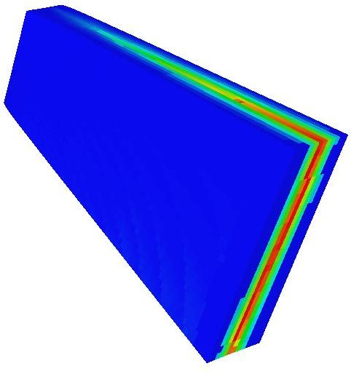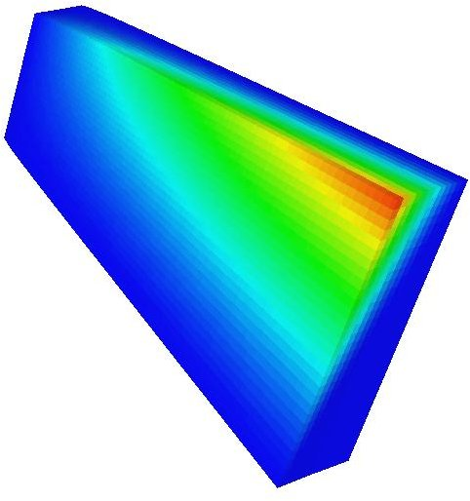
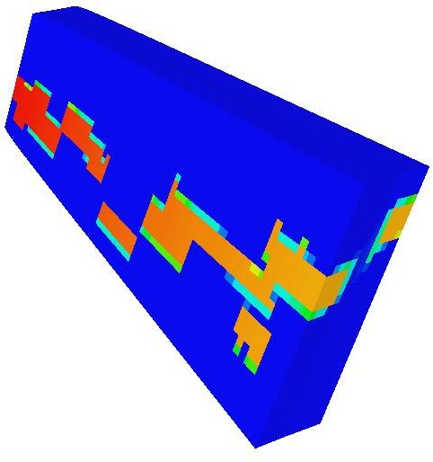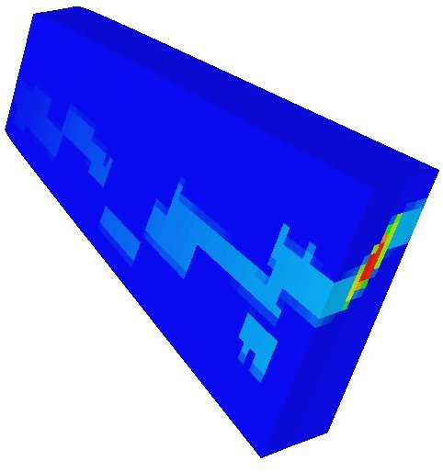

Figure 3: Intensity functions. Red indicates high values, blue indicates low values. Top left: Strain. Top right: ‘Upper facies intensity’. Bottom left: Intensity function for the least deformed sand facies. Bottom right: Intensity function for the most deformed sand.

In the fault zone, there are typically many different fault facies types representing various degrees of deformations of the facies originally present in the host rock volume affected by the fault. The degree of deformation is expressed by strain, and a strain model is used to honor the intensities for the different facies in the fault zone^{4,5}. In addition, facies originating from the footwall and hanging wall blocks above and below the volume represented in the model should be accounted for, as these can interact with the facies in the fault zone.

Figure 3 shows the intensity functions derived from the strain, and the intensity for the ‘upper’ facies, originating from the hanging wall block and the intensities if the least and most deformed sands. The most deformed facies are mainly located in the center of the fault zone, and the intensity is proportional to the strain. The ‘medium deformed’ facies are generally located between center and edge of the fault zone, and the least deformed facies mainly occur along the edges of the fault zone. In a detailed fault facies model, there is a continuous transition from the least deformed sand to the host rock sand.

Table 1: Host rock properties
Facies | Log(Kx) | Log(Ky) | Log(Kz) | Poro
Sand | 5.0 ± 0.5 | 5.0 ± 0.5 | 2.0 ± 0.5 | 0.20 ± 0.02
Shale | 1.5 ± 0.7 | 1.5 ± 0.7 | 0.5 ± 0.3 | 0.05 ± 0.03

The host rock consists of two sedimentary facies: high permeable sand objects in a background of shale cf. Table 1. During faulting, the shale transforms to four new background fault facies, and the sand objects are transformed to four new foreground fault facies representing different degrees of deformation. In Table 2, these deformed facies are labeled with numbers 1 to 4 signifying the levels of deformation. In addition, there are ‘upper’ and ‘lower’ elements originating from the hanging wall and footwall formations. In total, this gives 10 different fault facies to be distributed inside the fault zone. One of the background facies and one foreground facies, both located at the edges of the fault zone, are modeled as ellipsoids in an object model1⁶, and represent lenses in the fault zone. The rest of the facies are modeled using sequential indicator simulation⁷.

Table 2: Fault zone properties
Facies | Log(Kx) | Log(Ky) | Log(Kz) | Poro
Sand 1 | 5.0 ± 0.7 | 5.0 ± 0.7 | 2.0 ± 0.3 | 0.20 ± 0.03
Sand 2 | 4.3 ± 0.5 | 2.5 ± 0.5 | 4.1 ± 0.5 | 0.20 ± 0.05
Sand 3 | 3.2 ± 0.5 | 1.5 ± 0.5 | 3.0 ± 0.5 | 0.15 ± 0.04
Sand 4 | 2.0 ± 0.5 | 0.8 ± 0.5 | 1.8 ± 0.5 | 0.10 ± 0.03
Shale 1 | 1.5 ± 0.7 | 1.5 ± 0.7 | 0.5 ± 0.3 | 0.05 ± 0.03
Shale 2 | 1.4 ± 0.5 | 0.5 ± 0.5 | 1.2 ± 0.5 | 0.03 ± 0.012
Shale 3 | 0.0 ± 0.5 | -0.8 ± 0.5 | -0.1 ± 0.5 | 0.02 ± 0.008
Shale 4 | -1.4 ± 0.5 | -2.0 ± 0.5 | -1.6 ± 0.5 | 0.01 ± 0.007
Upper | 0.03 ± 0.005 |  |  | 0.05 ± 0.005
Lower | 0.03 ± 0.005 |  |  | 0.05 ± 0.005

Permeability and porosity are modeled for all facies, using transformed Gaussian random fields. Facies located in the center of the fault zone are most deformed, and have the lowest permeability. For the lenses, permeability is given an intra-body trend. Figure 4 depicts the horizontal permeability in the fault zone in a single realization before and after upscaling. For permeability, we have used the diagonal tensor⁸ method, and for porosity, we used arithmetic upscaling.
displays one realization of the permeability in the whole reservoir.

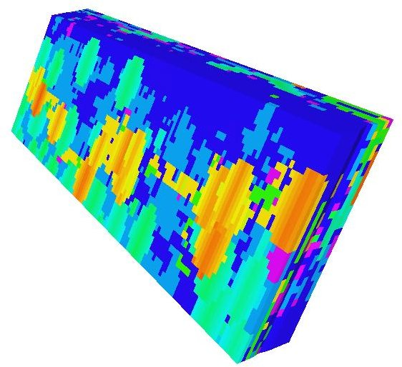 | 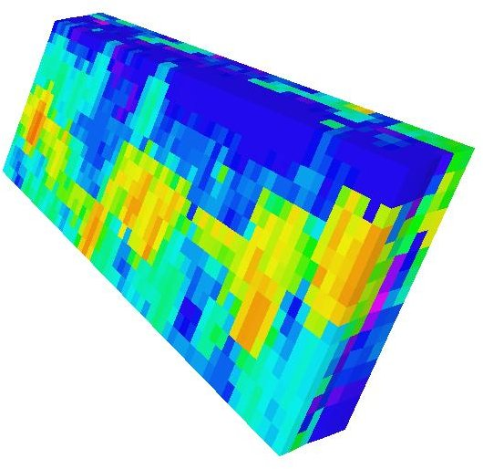 | 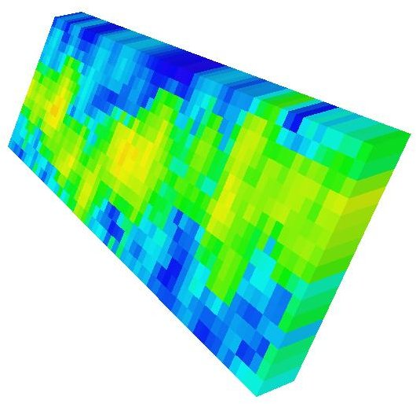

Figure 4: Transverse horizontal permeability in fault zone before and after two levels of upscaling; in the transverse direction there are 12, 6, and 1 grid cells, respectively. The fault lens objects are clearly visible on the fine scale.

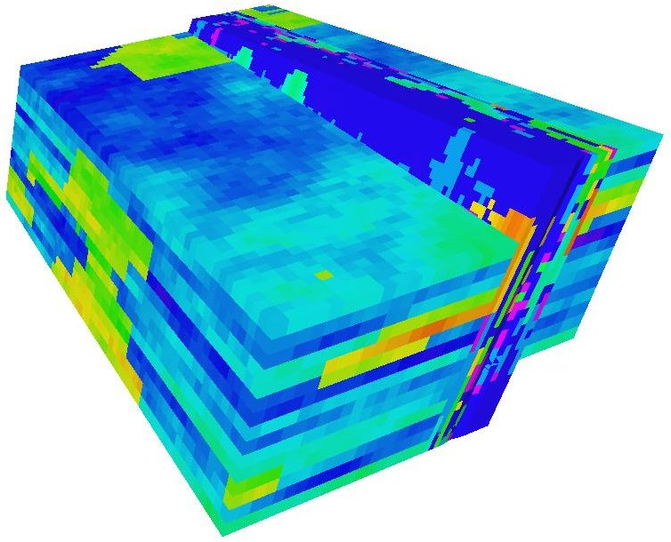 | 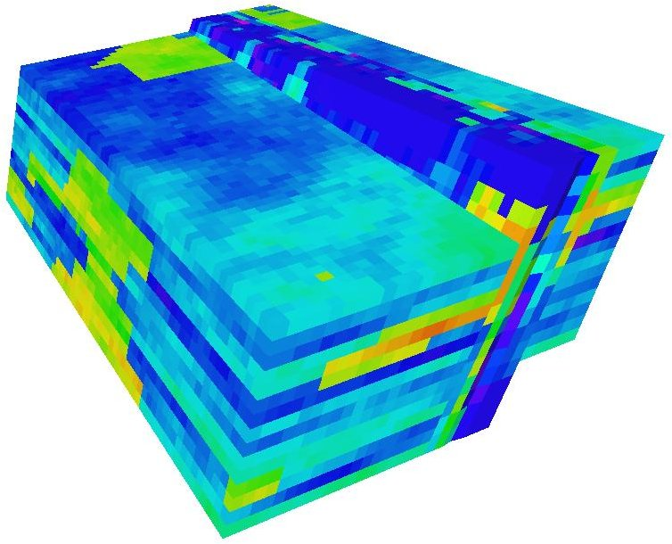 | 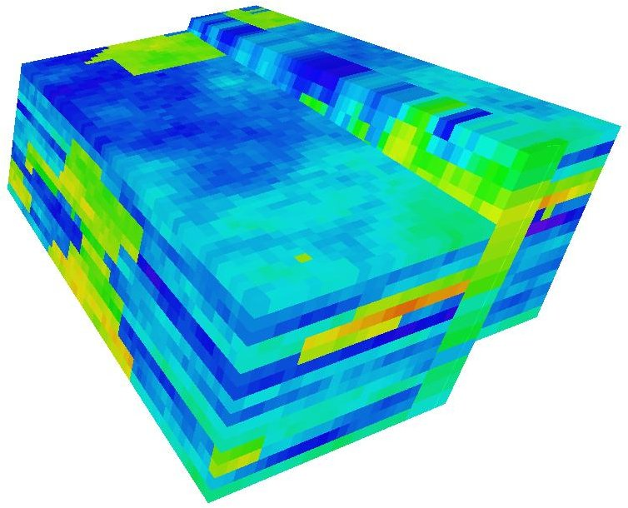

Figure 5: Horizontal permeability in the whole reservoir, before and after two levels of upscaling of the fault zone.

Figure 6: Water cut versus time in days. The figure shows water cut for 100 fault facies realizations (blue, green and orange). The blue curves correspond to the fine scale fault zone model, and the green and orange to two levels of upscaling. The brown curves represent the conventional model.

Results

We generated 100 fault facies realizations and upscaled them to various degrees while keeping the reservoir outside the fault zone constant. To compare we also generated a conventional model with the fault surface modeled with transmissibility multipliers and non-neighboring connections augmented with ad hoc uncorrelated random noise. Thus, we generated 100 stochastic conventional realizations. Using an industry standard simulator we then performed flow simulations on all of these using a single rate-limited water injector on one side of the fault, and a rate-limited oil producer on the other side. We let the simulations run for 5611 days. Results are shown in Figure 6–9.

Water cut
In the fine scale fault facies model we observed water break-through in the producer after about 600 ± 200 days, see top left of Figure 6. In the most upscaled case, water break-through occurred later at about 800 ±200 days (Figure 6, bottom left). The conventional multiplier model shows a later water break-through around 2000 days.

Oil production
The total oil production, see Figure 7, has a somewhat different distribution in the fine scaled and upscaled cases.

The oil production rates are strongly influenced by the water break-through. Hence the oil rates, see Figure 8, show a marked drop at the time of water break-through.

Gas/oil ratio
The gas/oil ratio is increasing at around 3000 days, see Figure 9. Note that the rate of increase depends on the upscaling level. Also, note that the conventional model gives a gas/oil ratio curve with a behavior that differs a bit from that of the fault facies realizations.

Figure 7: Distributions of total oil production for fine scale (blue), medium upscaled (green) and highly upscaled (orange) fault facies models. The brown bars show the results of the conventional model.

Figure 8: Oil production rate versus time in days before and after various levels of upscaling. The figure shows production curves for 100 fault facies realizations (blue, green, and orange curves) and 100 conventional realizations (in brown).

Figure 9: Gas/oil ratio versus time in days before and after various levels of upscaling. The figure shows results for 100 fault facies realizations (blue, green, and orange curves) and 100 conventional realizations (in brown).

Concluding remarks

We have compared the results of flow simulation in a fault facies model with a model using the conventional fault representation. For water cut and gas-oil ratio we find significant differences between the fault facies model and the conventional models. Not only are the times for breakthrough of water and gas different—the overall shape of the curves differs: in the present case, this is most obvious for the gas-oil ratio, but in other cases, we have seen similar differences for water cut curves. Hence, the differences are problem-dependent.

The most significant advantage of the fault facies approach is
that is gives a direct and physical handle on the uncertainties produced by thick fault zones and allows the direct implementation of geological data from faulted rock volumes in the reservoir model. This is not to say that these uncertainties are impossible to model by the conventional method.

However, detailed modeling does not come without a price tag. Each fine scale flow simulation took more than five hours where as the conventional model was done in two minutes. Hence, in practice the fault facies approach requires upscaling and a careful choice of the initial grid resolution of the fault zone.

We applied a simple diagonal tensor 1-phase permeability-upscaling algorithm in a commercial software package, and found the following results: upscaled models have a larger cumulative oil production than the fine scale models. This is due to later water breakthrough and lower gas ratios in the upscaled models. Looking at Figure 4, one immediately observes that blue impermeable regions on the left turns green on the most upscaled picture on the right meaning that this upscaling method opens up barriers. Our conclusion is that highly inhomogeneous fault zones demand upscaling methods better suited to preserve the flow patterns than the method used in this paper.

References

1. Tveranger, J., Braathen, A., Skar, T. and Skauge, A. (2005): Centre for Integrated Petroleum Research: Research with emphasis on fluid flow in fault zones. Norwegian Journal of Geology 85, 63–71.

2. Manzocchi, T., Walsh, H.J., Nell, P.A.R., and Yielding, G. (1999): Fault transmissibility multipliers for flow simulation model. Petroleum Geoscience 5, 53–63.

3. Syversveen, A.R., Skorstad, A., Soleng, H.H, Røe, P. and Tveranger, J. (2006): Facies modeling in Fault Zones. Proceedings from 10th European Conference on the Mathematics of oil Recovery (ECMOR X), Amsterdam, The Netherlands.

4. Røe, P. and Soleng, H.H. (2006): Strain calculations in Havana. Algorithm and implementation. SAND/10/06.

5. Cardozo, N., Røe, P., Soleng, H.H., Fredman, N., Tveranger, J., and Schueller, S. (2007): A methodology for efficiently populating faulted corner point grids with strain. Petroleum Geoscience (submitted for publication).

6. Lien, A. L. and Syversveen, A. R. (2000): Marked point model of facies objects conditioned to seismic data and well data. GEOSTAT 2000, Cape Town, South Africa, 6th International Geostatistical Congress.

7. Deutsch, C. V. and Journel A. G. (1992): GSLIB. Geostatistical SOftware Library and User’s Guide.Oxford University Press.

8.Irap RMS 8.1.1 User Guide (2007): Roxar Software Solutions.

